November 30th, 2017

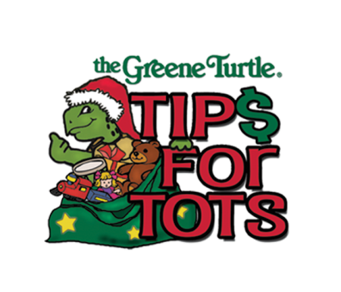

The Greene Turtle Sports Bar & Grille® Announces 12th Annual Tips for Tots Holiday Initiative on December 13
The Greene Turtle Sports Bar & Grille® employees will donate 100 percent of the tips they earn on December 13 to Toys for Tots to give local children a happier holiday season

Columbia, MD – Today, The Greene Turtle Sports Bar and Grille® announces the launch of its 12th annual “Tips for Tots” initiative on Wednesday, December 13. The restaurant has set a goal to raise $100,000 worth of toys for Toys for Tots.

Last year, The Greene Turtle Sports Bar & Grille® surpassed their goal of $90,000 by raising $93,422. This year, the restaurant increased their goal by $10,000 with hopes of making an even bigger impact in the community. To date, the Tips for Tots initiative has raised over $333,000 in its 11 years.

Employees at The Greene Turtle Sports Bar & Grille®’s 43 participating locations will donate 100 percent of the tips they earn on Wednesday, December 13 to Toys for Tots across communities in Maryland, Delaware, New York, Virginia, West Virginia and Washington, D.C. The Greene Turtle Franchising Corporation will add a matching $500 donation for each participating location that earns $1,000 in tips. With the money that each of the 43 participating locations raises, the restaurant’s employees will shop at local stores to buy toys to donate to Toys for Tots.

“The Greene Turtle is thrilled to continue our Tips for Tots initiative this year in partnership with our incredibly giving employees,” said Layla Nielsen, Senior Director of Marketing at The Greene Turtle Sports Bar & Grille®. “Please join us on December 13 to dine and help make an even greater impact on the community during the holiday season.”

"Tips for Tots" was the selfless idea of Corlie Brice, a bartender at The Greene Turtle Sports Bar & Grille® in Salisbury, MD in 2006. She arrived for her shift and noticed a sign on the neighboring business, designating it as a Toys for Tots drop-off site. She decided to use whatever tips she took in during her shift to purchase toys for the program. Additionally, she enlisted her fellow employees and publicized her intentions to guests coming into the restaurant to increase the potential donation. That evening, she and fellow bartender, Chris Tingle, took in $700. Since then, the initiative has grown to include 43 locations in six markets and has raised over $333,000.

About The Greene Turtle Sports Bar & Grille® and The Greene Turtle Franchising Corp.:
First opened in Ocean City, MD., in 1976, The Greene Turtle Sports Bar & Grille® today includes 46 locations in markets across Maryland and extending into Washington, D.C., Virginia, West Virginia, Delaware, Pennsylvania, New Jersey and Long Island, New York. Combining comfort food, a casual atmosphere and a sports bar theme marked by big screen TVs broadcasting local and national events, “The Turtle” has become a popular year-round destination where families, friends and fans of all ages feel at home. CBS Baltimore named The Greene Turtle Sports Bar & Grille® among the best local spots to enjoy “March Madness.” Information is available online at www.thegreeneturtle.com and www.facebook.com/thegreeneturtle.

# # #

MEDIA CONTACT: Monique Smallow Shannon Stern
Maroon PR Maroon PR
443-832-5158 443-695-8235
Monique@MaroonPR.com Shannon@MaroonPR.com

