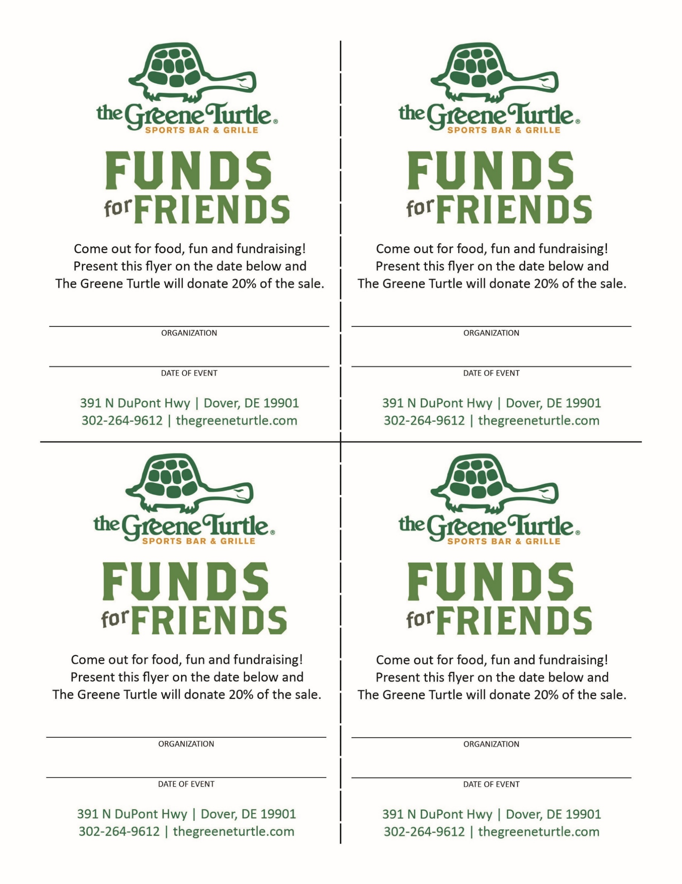

TYPE HERE

TYPE HERE

TYPE HERE

TYPE HERE

TYPE HERE

TYPE HERE

TYPE HERE

TYPE HERE

**307 Rocky Run Pkwy.  
Wilmington, DE 19803  
(302) 510-6166**

**307 Rocky Run Pkwy.  
Wilmington, DE 19803  
(302) 510-6166**

**307 Rocky Run Pkwy.  
Wilmington, DE 19803  
(302) 510-6166**

**307 Rocky Run Pkwy.  
Wilmington, DE 19803  
(302) 510-6166**