**STEP 1**

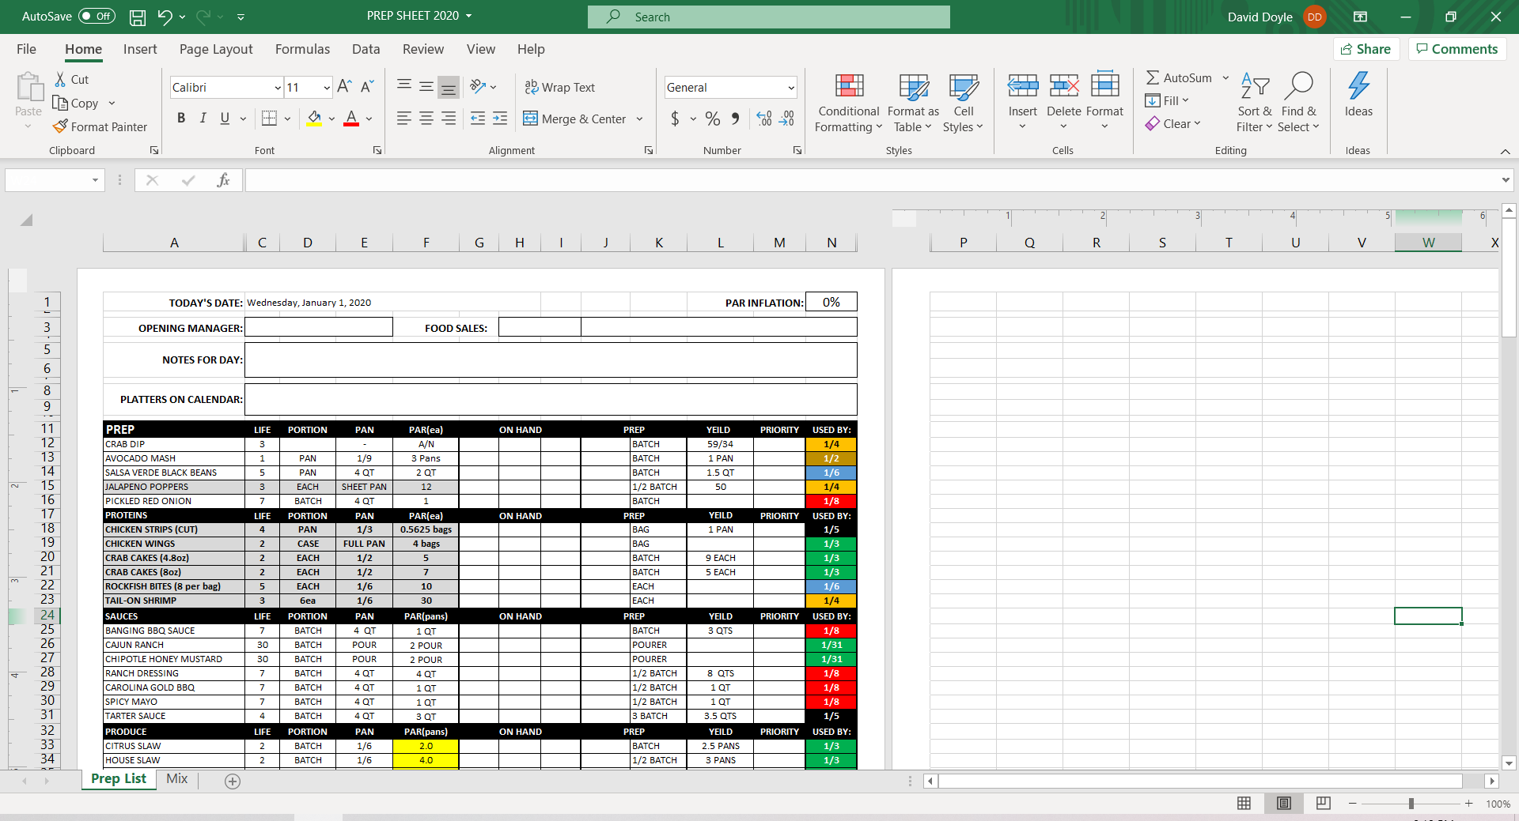

Insert Date, Manager Name, Notes & Platters

**STEP 2**

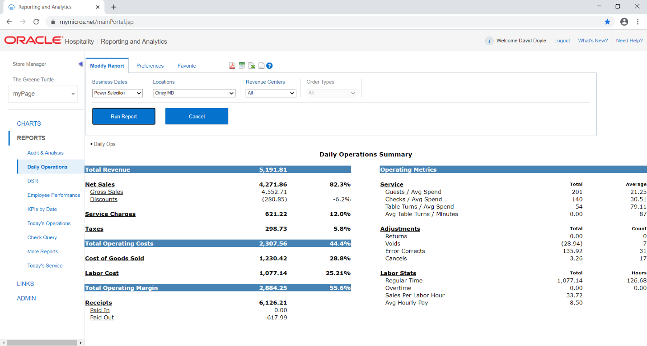

MyMicros, Daily Operations, Change date, Run Report, Select Net Sales

**STEP 3**

Select Food for a Full Break Down

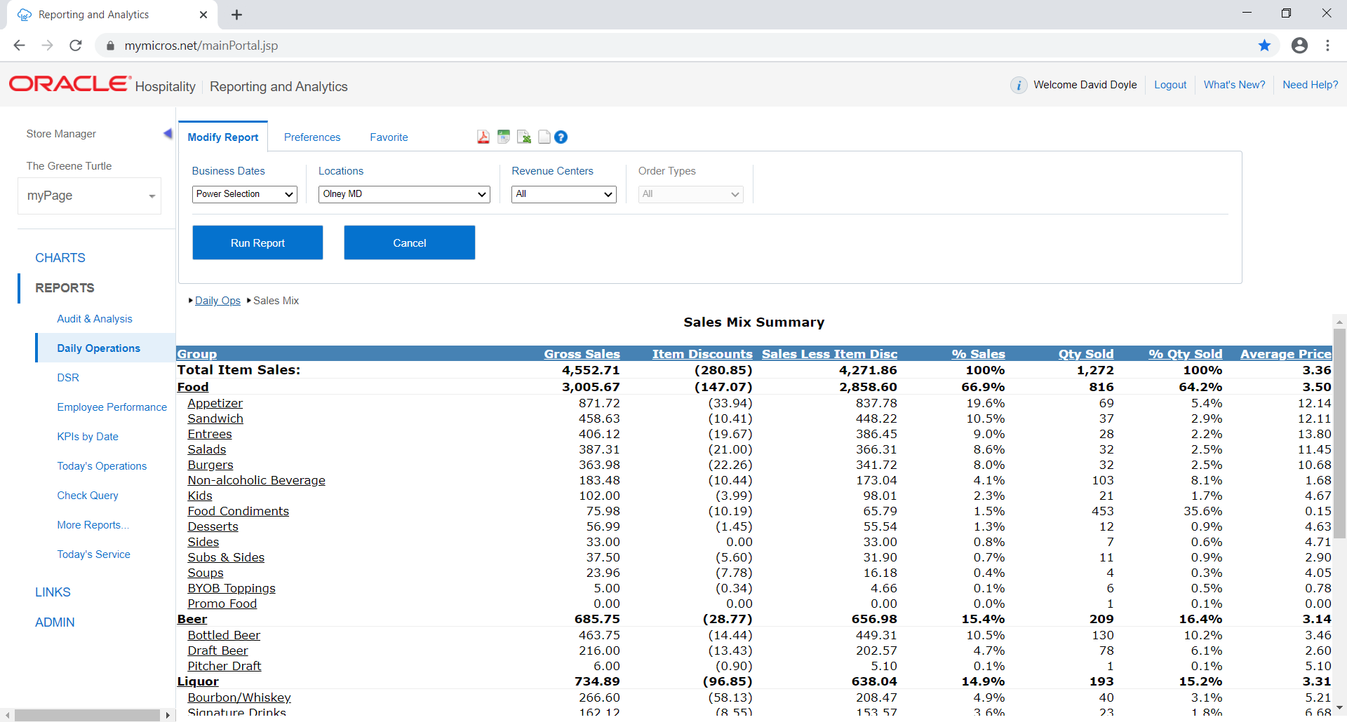

**STEP 4**

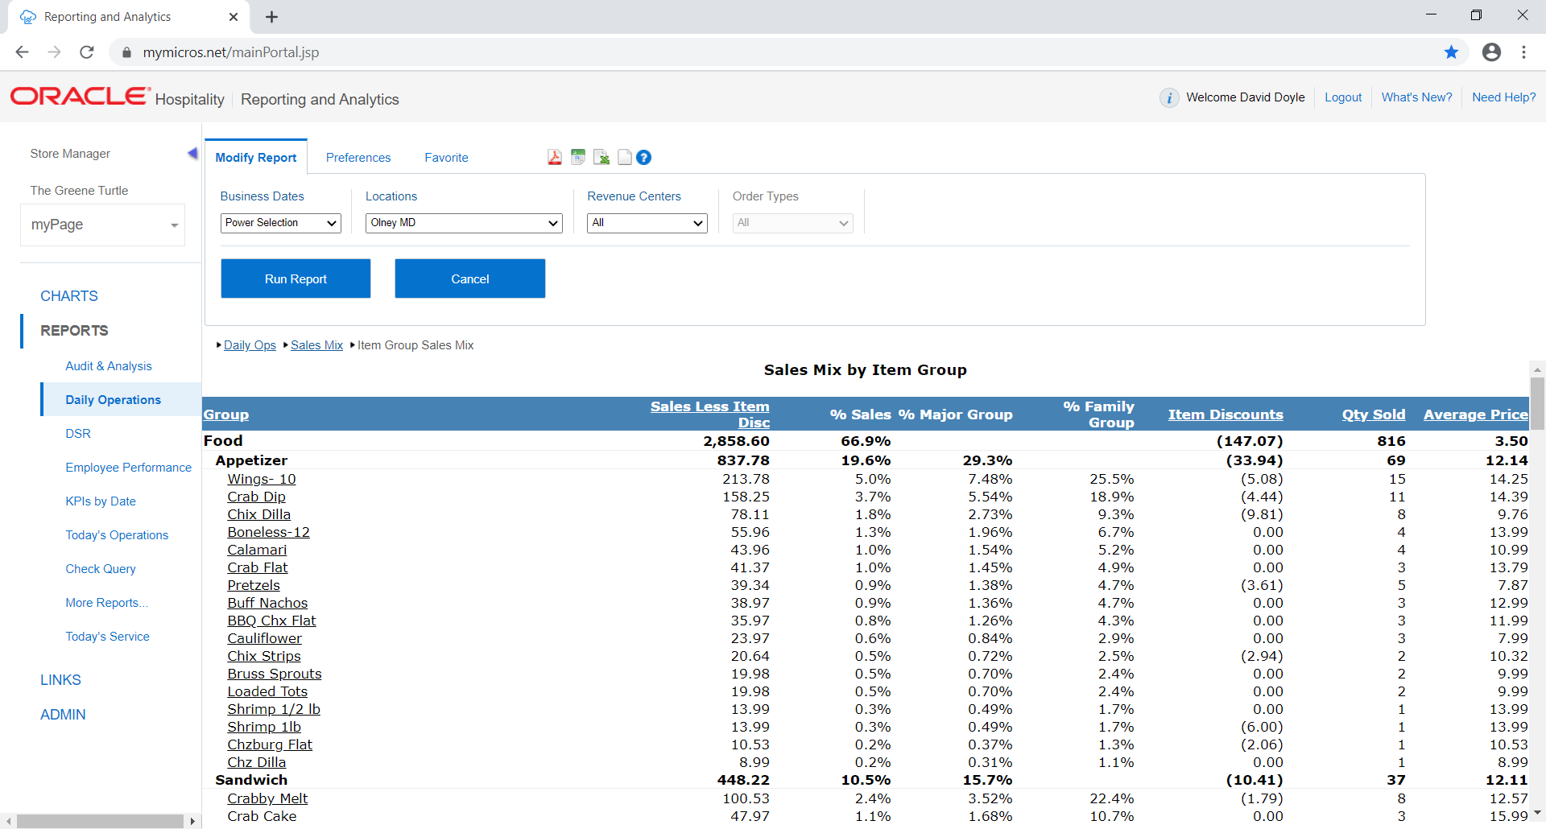

Select to Export to Microsoft Excel

**STEP 5**

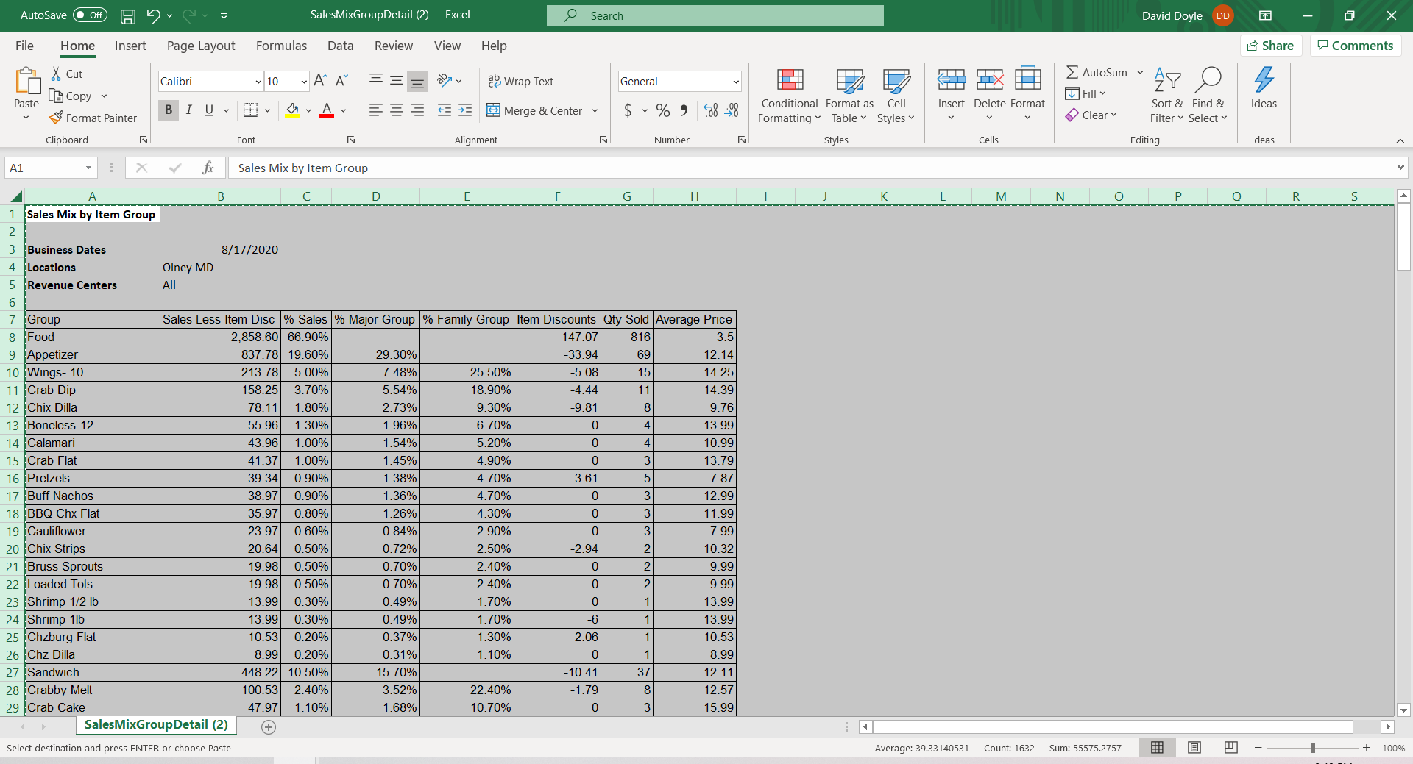

Click Top Left Corner to Highlight All, Right click, copy

**STEP 6**

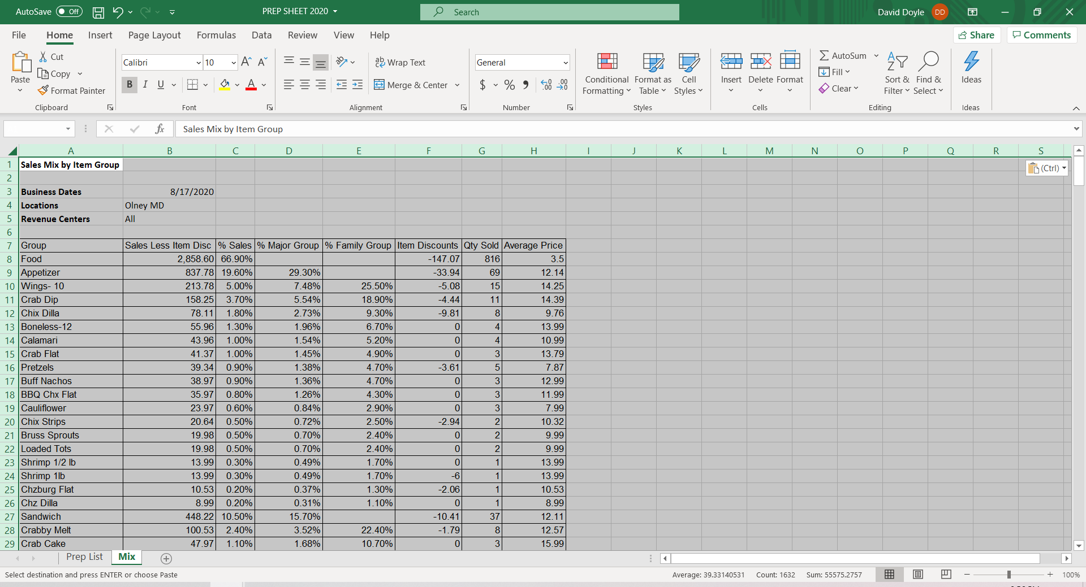

Open Prep Sheet, Select Mix, Copy & paste in the top left box

**STEP 7**

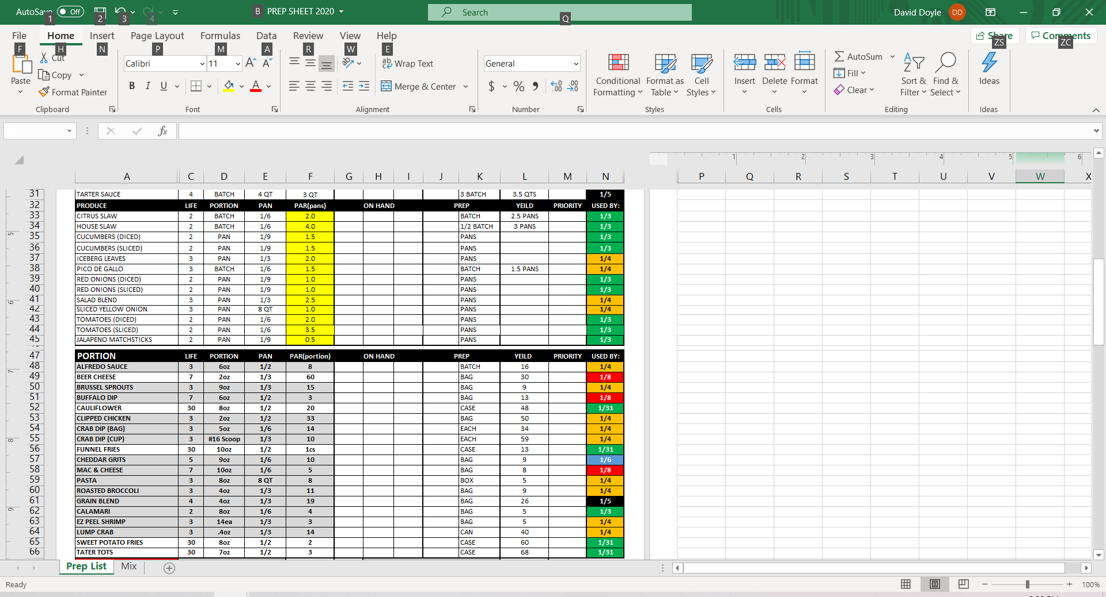

Select Prep List, Pars will Update from last weeks Sales

**STEP 8**

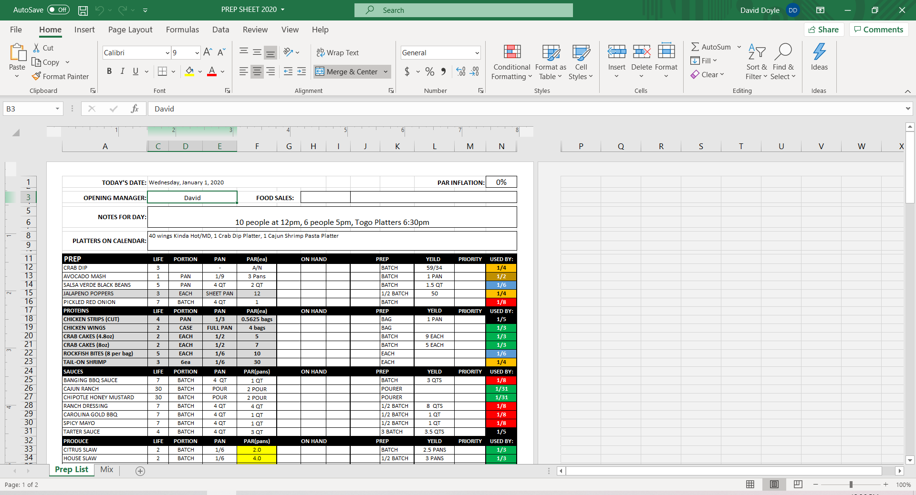

Increase Par Inflation based on Projections and last weeks sales